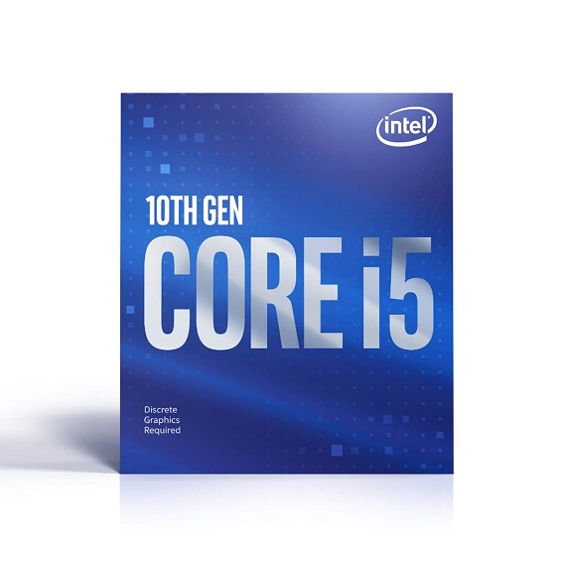

Inner

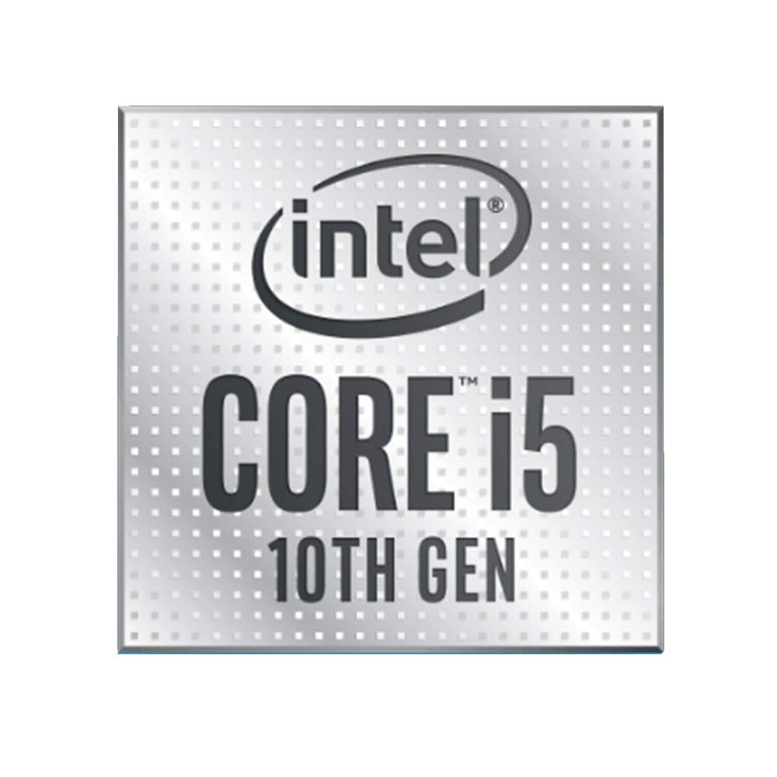

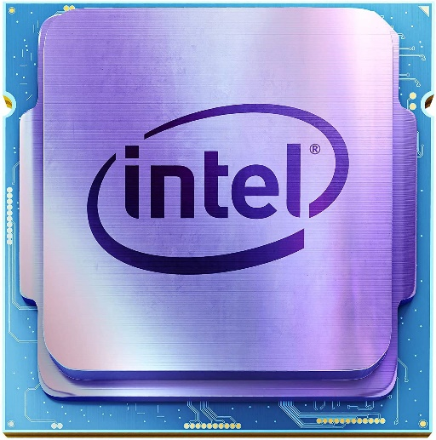

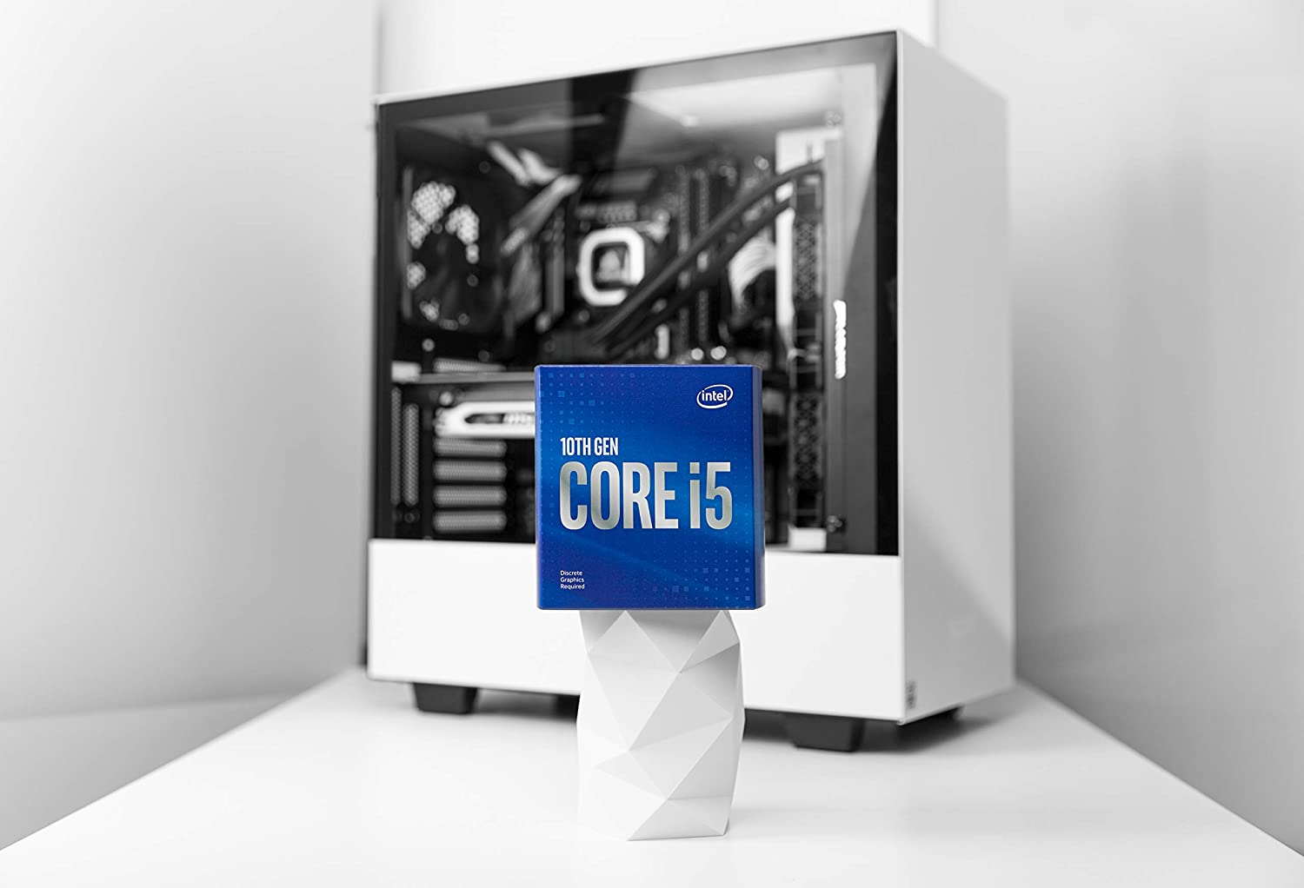

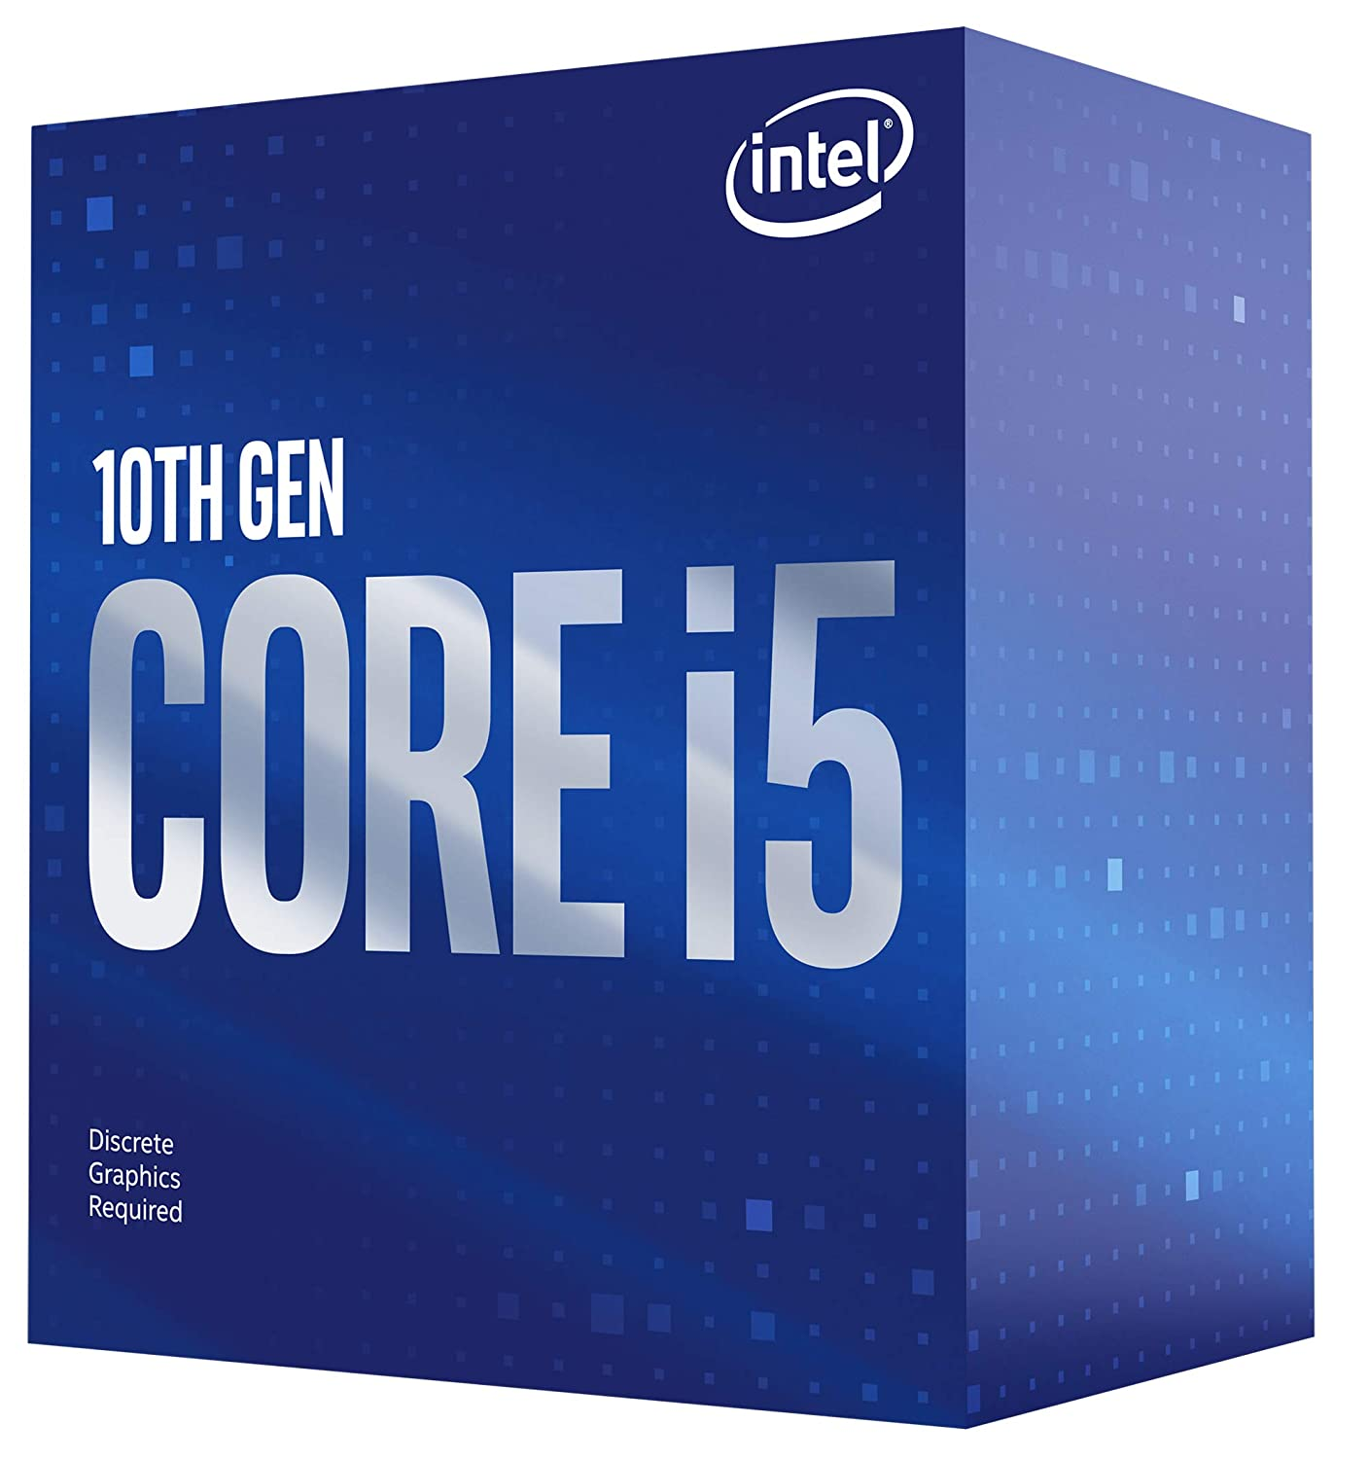

Intel Core i5-10400F 10th Generation Processor with 12MB Cache Memory 6 Cores 12 Threads and 3 Years Warranty (Comes with Fan Inside The Box)

-38% ₹11,629.00

M.R.P.: ₹18,870.00

|  |  |
| --- | --- |
| Brand | Intel |
| CPU Manufacturer | Intel |
| CPU Model | Core_m |
| CPU Speed | 2.9 GHz |
| CPU Socket | LGA1200 |

**About this item**

* Processor- i5 -10400F , BX8070110400F
* Intel Core i5-10400F Processor (12M Cache, up to 4.30 GHz)10th Generation Intel Core i5 ProcessorsProducts formerly Comet LakeDesktopLithography14 nmProcessor Base Frequency2.90 GHzSockets SupportedFCLGA1200
* Intel Core i5-10400F Processor (12M Cache, up to 4.30 GHz)
* Compatible chipsets : Intel Q470 Chipset, Intel Z490 Chipset, Intel H470 Chipset, Intel B460 Chipset, Intel H410 Chipset
* Processor- i5 -10400F , BX8070110400F
* Intel Core i5-10400F Processor (12M Cache, up to 4.30 GHz)10th Generation Intel Core i5 ProcessorsProducts formerly Comet LakeDesktopLithography14 nmProcessor Base Frequency2.90 GHzSockets SupportedFCLGA1200
* Intel Core i5-10400F Processor (12M Cache, up to 4.30 GHz)
* Compatible chipsets : Intel Q470 Chipset, Intel Z490 Chipset, Intel H470 Chipset, Intel B460 Chipset, Intel H410 Chipset